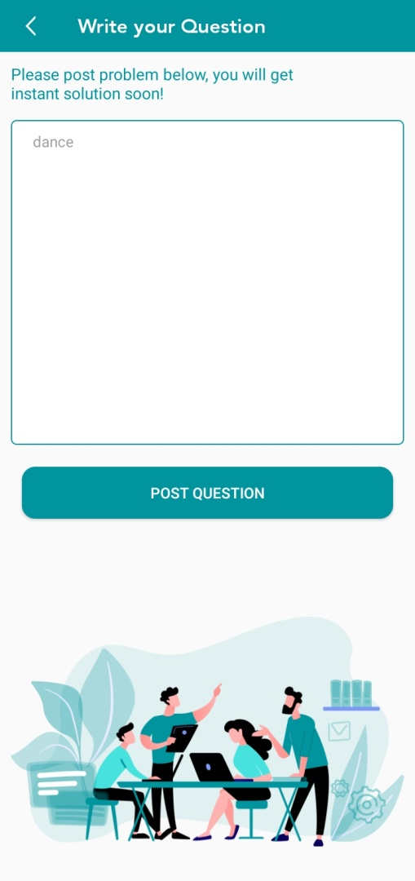



Api :-BaseUrl +/Tag/getAllTag  
method :- Get  
This api maven site get All Get Tag by Search option  
  
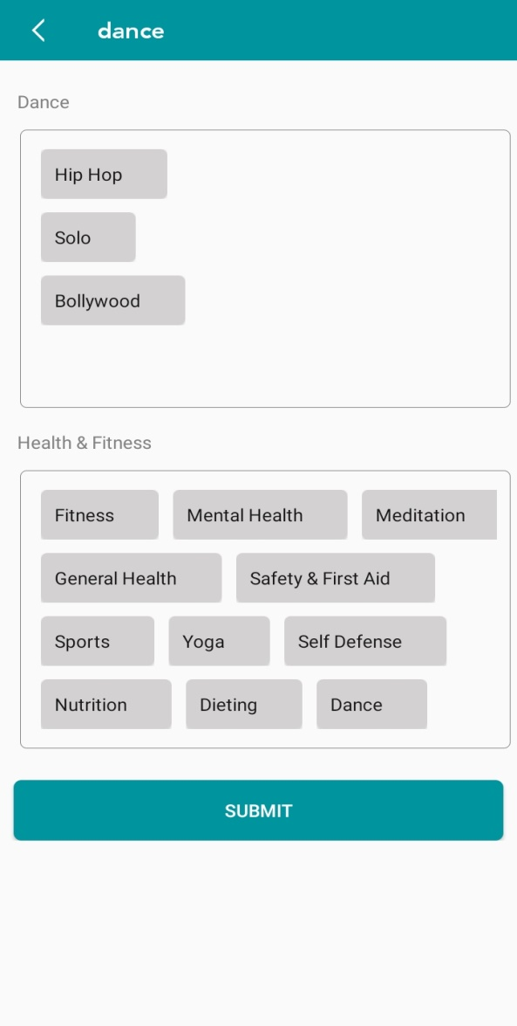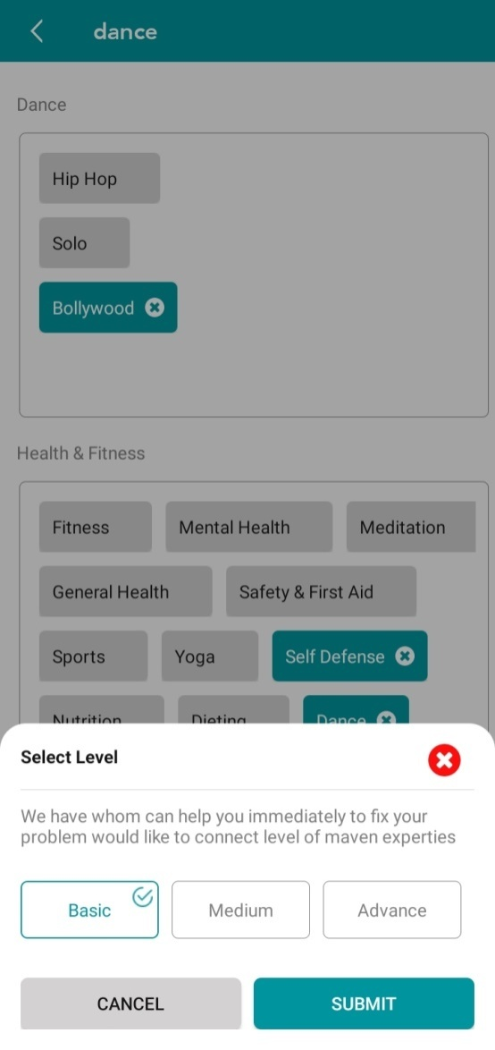

Api:-BaseUrl +/skills/MavanowSearchEngine

Method :- POST

This Screen Search Category wise skills through Tags and Question

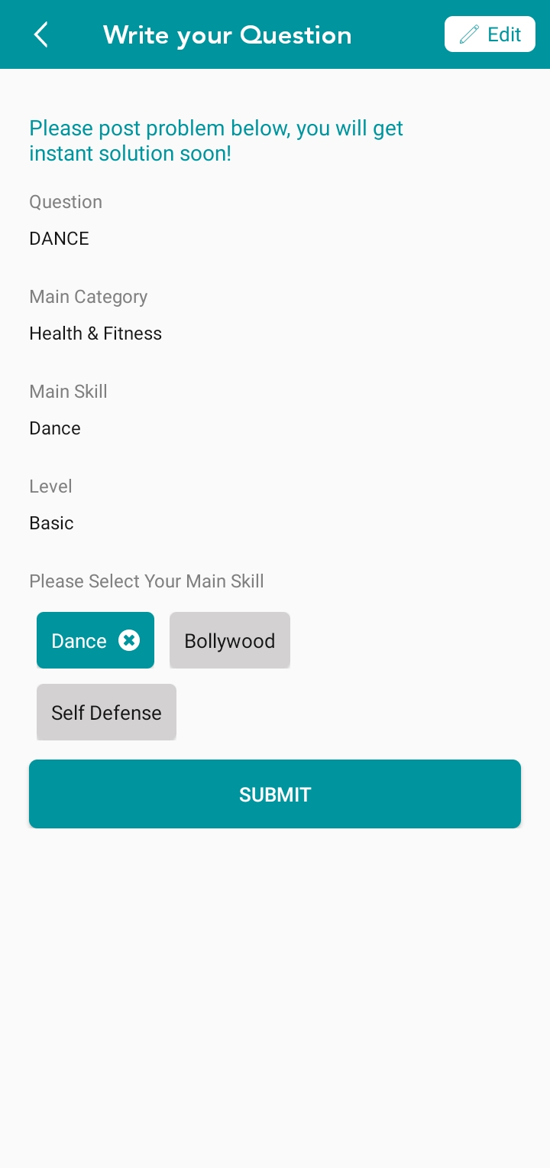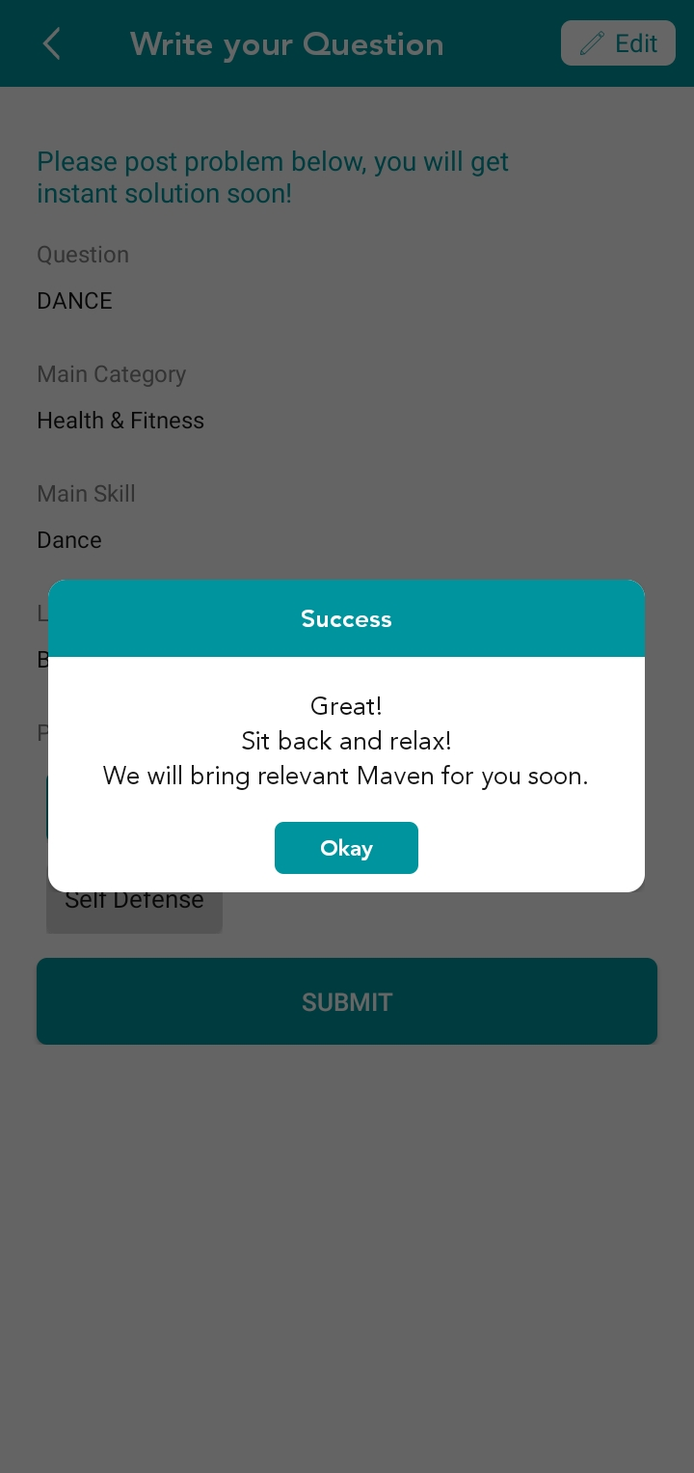

Api:-BaseUrl + /userrequest/addUserrequestbyquestion?token=

Method :- POST

This Api used Learner request create after login and before login re-direct login screen with data

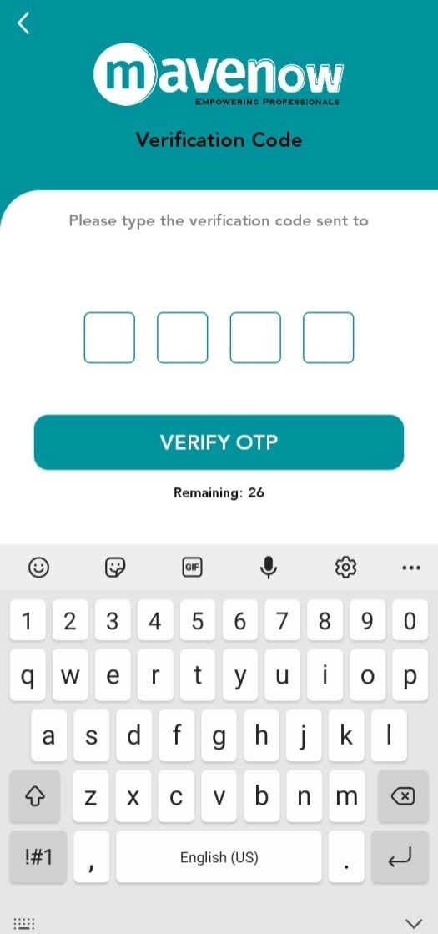

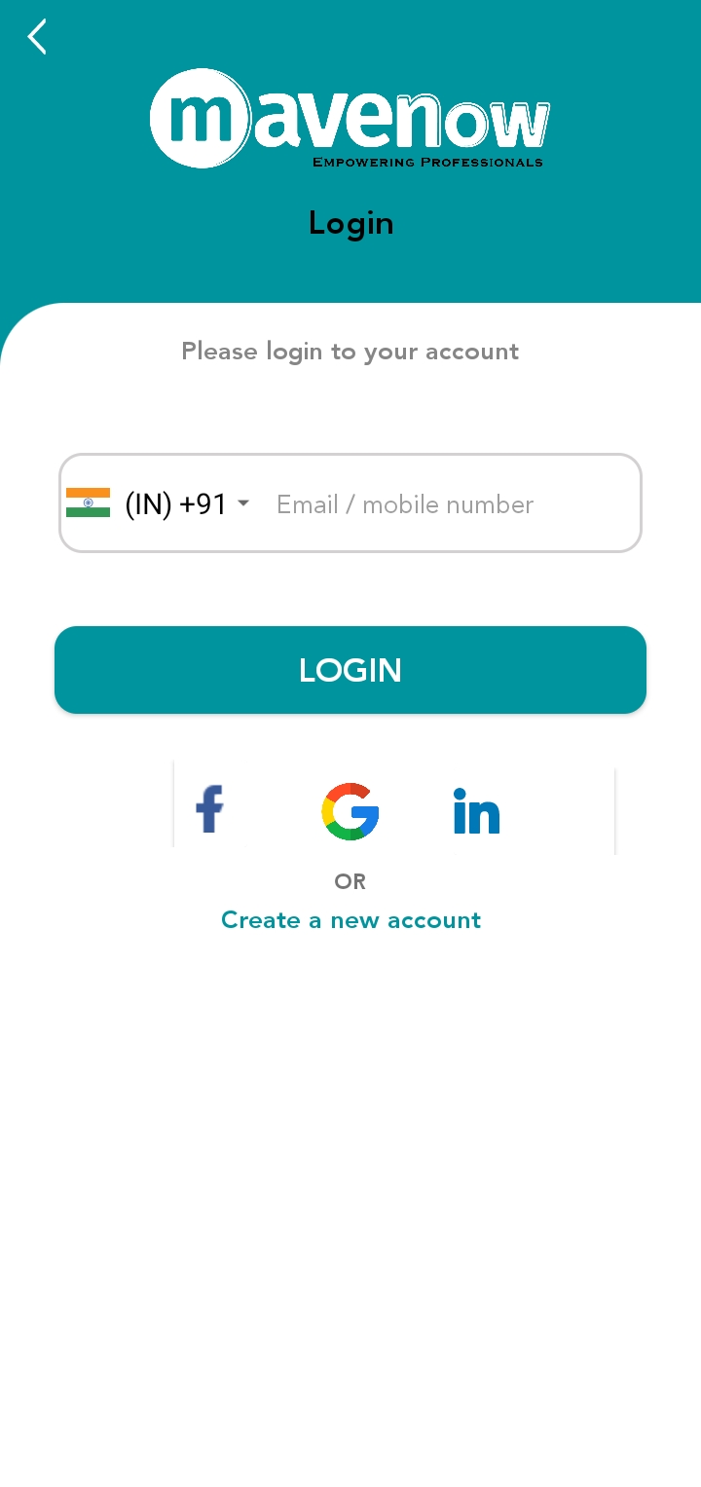

Api:-BaseUrl +/**user/**loginotp

Method :- POST

This Api used Send Otp

Api:-BaseUrl +/user/loginOtpVerify

Method :- POST

This Api used Verify Otp

Api:-BaseUrl +/user/register

Method :- POST

This Api used register user by Facebook, Gmail, LinkedIn one time register and second time only without data

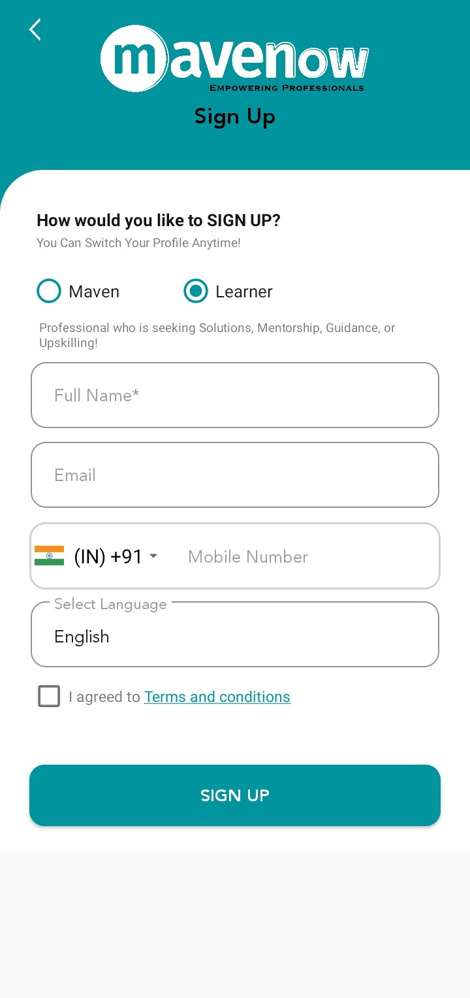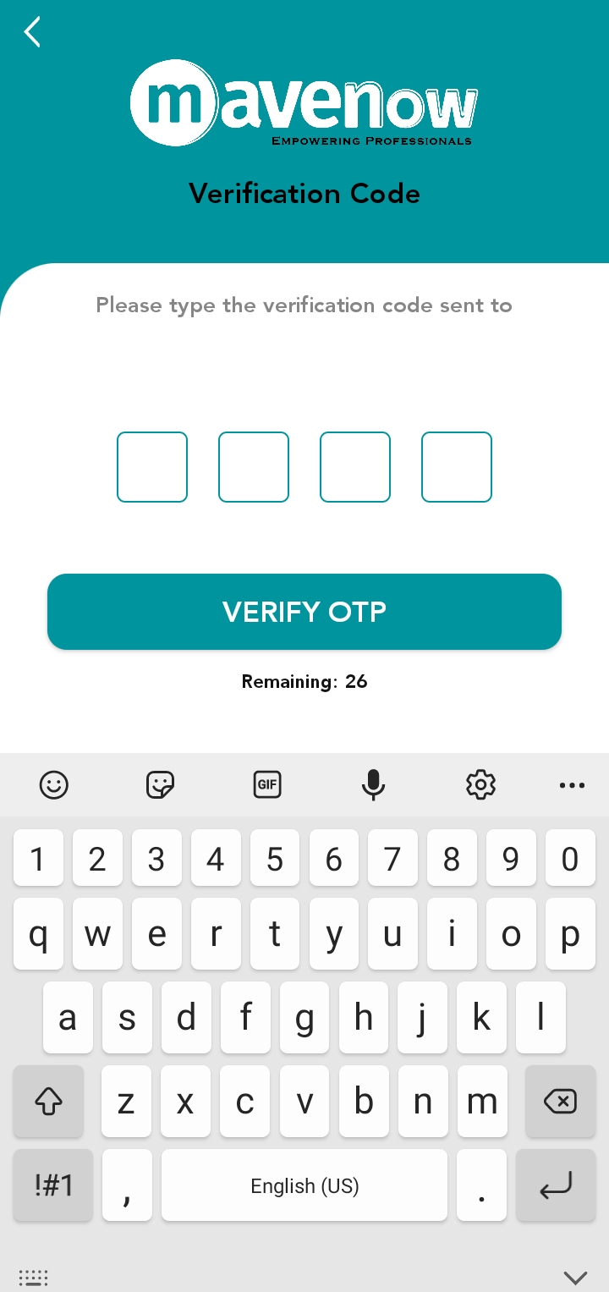

Api:-BaseUrl +/registration/otp

Method :- POST

This Api used Send Otp register user

Api:-BaseUrl +/varified/otp

Method :- POST

This Api used Verify Otp register user

Api:-BaseUrl +/user/register

Method :- POST

This Api used register user with request create

Api: BaseUrl +/user/GetLanguages  
Method: -Get This Api used Get language for register user

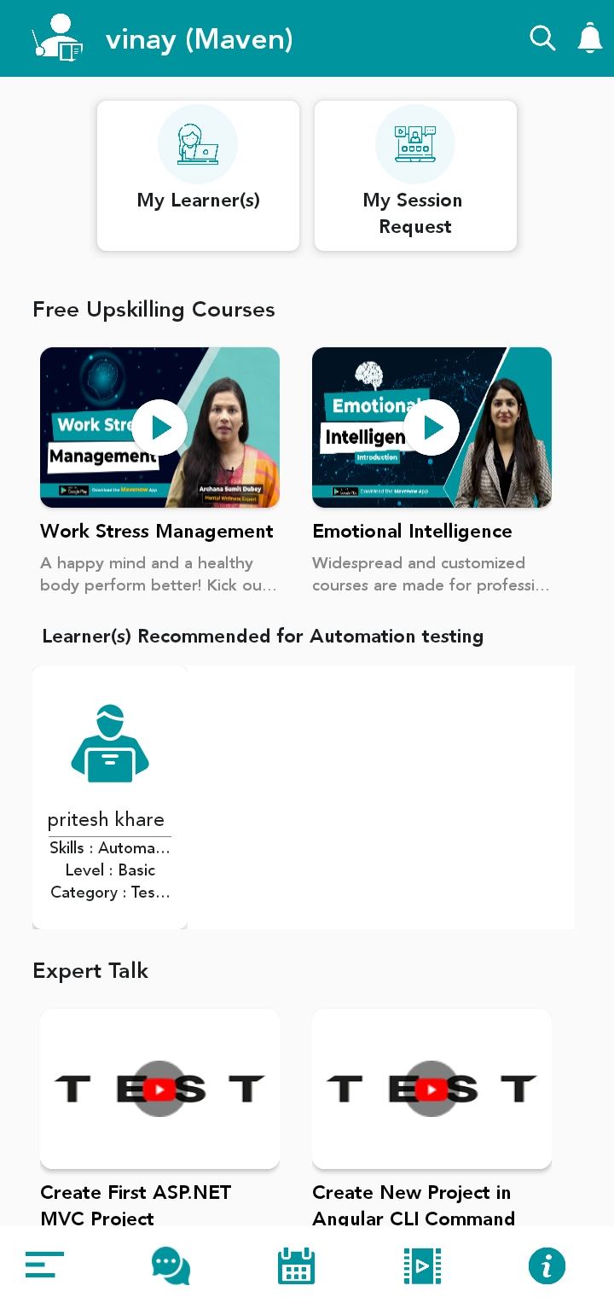

Api:-BaseUrl +/SettingImage/getSettingImage

Method :- POST

This Api used Get Banner image

Api:- BaseUrl +/dashboardData/foruser  
Method :- Post  
This Api used Get Dashboard Data  
  
Api:- BaseUrl +/logout  
Method :- Post  
This Api used Get Dashboard Data  
  
Api:- BaseUrl +/course/GetAllRecommendedCourses  
Method :- Post  
This Api used GetAllRecommendedCourses  
  
Api:- BaseUrl +/ GetAllMentors  
Method :- Post  
This Api used GetAllMentorsCourses

Api:-BaseUrl +/ course/GethiglightVideosForApp  
Method :- Post  
This Api used Get highlight Videos list ForApp

Api:-BaseUrl +/ gethighLightedExpertLink  
Method :- Post  
This Api used Get highlight YoutubeVideos list ForApp

Api:-BaseUrl +/pageContent  
Method :- Post  
This Api used Help dialog learner and maven

Api:-BaseUrl +/user/settimezone  
Method :- Post  
This Api used settimezone

Api:-BaseUrl +/user  
Method :- Post  
This Api used Get Profile User Data

Api :-<https://mavenow-a551c-default-rtdb.firebaseio.com/users.json>  
Method :- Get  
This api used get User list using Firebase

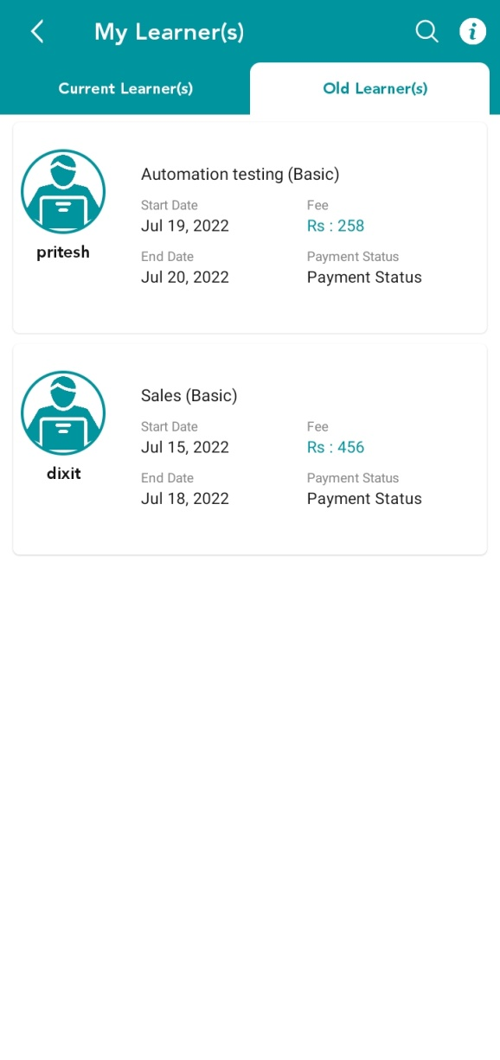

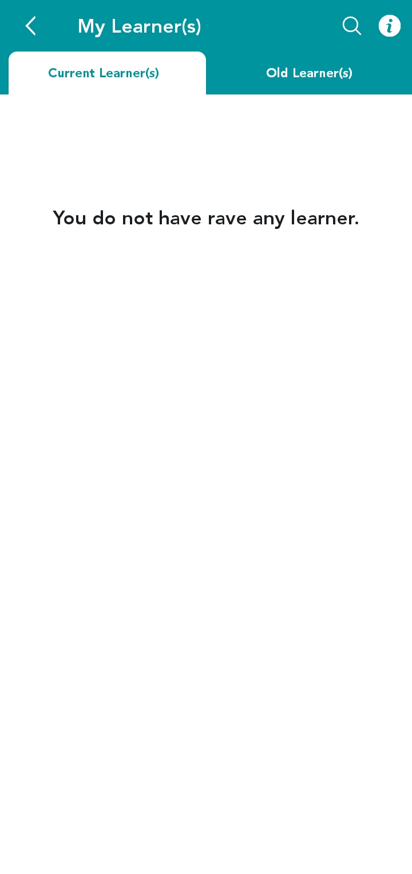

Api:-BaseUrl +/user/discipleOrMaster  
Method :- Post  
This Api used Get New and old learner

Api:-BaseUrl +/pageContent  
Method :- Post  
This Api used Help dialog learner and maven

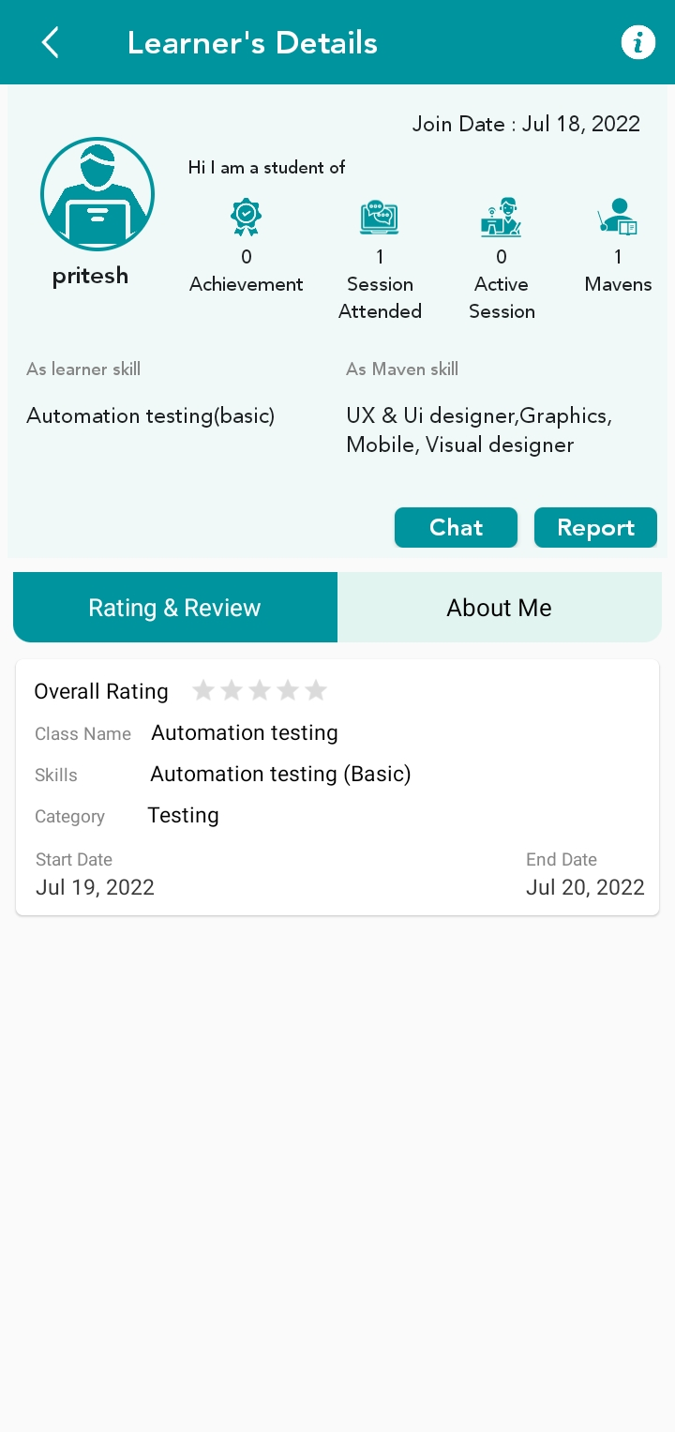

Api:-BaseUrl +/userrequest/getUserClassesByRating  
Method :- Get  
This Api used getUserClassesByRating

------------------------------------------------------------

Api:-BaseUrl +/reportedUser  
Method :- Post   
This Api used reportedUser

------------------------------------------------------------------

Api:-BaseUrl +/ user  
Method :- Get   
This Api used Get Profile Data User

-----------------------------------------------------------------------

Api:-BaseUrl +/add/Wallet/TransactionDetail  
Method :- Post   
This Api used TransactionDetailWallet Add

Api:-BaseUrl +/userrequest/hireCandidate  
Method :- Post   
This Api used hireCandidate join

**Badges Screen, Review Screen**  
  
Api:-BaseUrl +/badges/byUserId  
Method :- Get   
This Api used get badges

Api:-BaseUrl +/user/feedback

Method :- Get   
This Api used get feedback Review

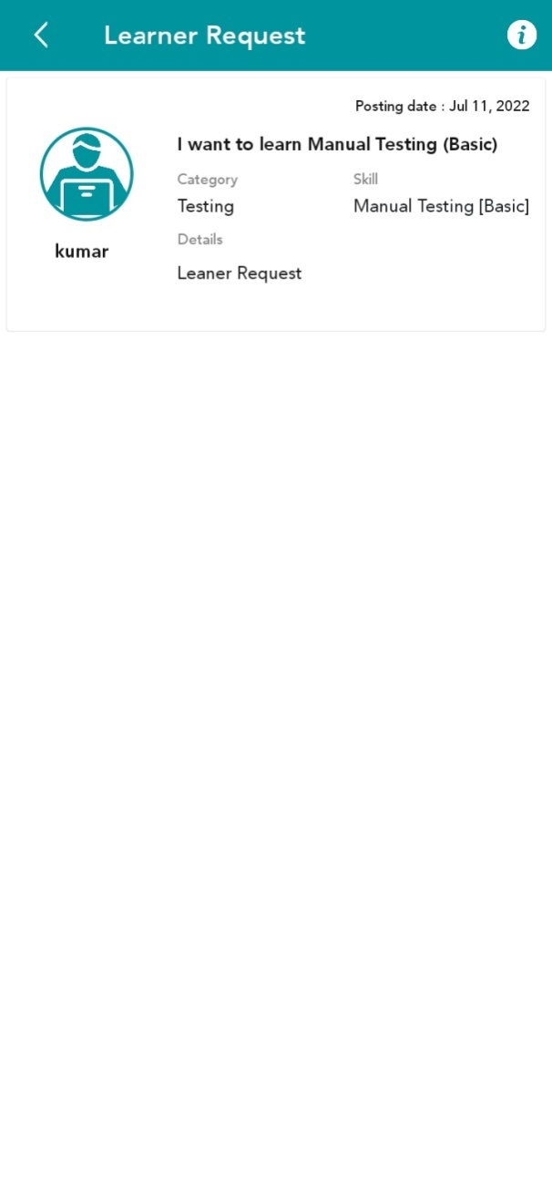

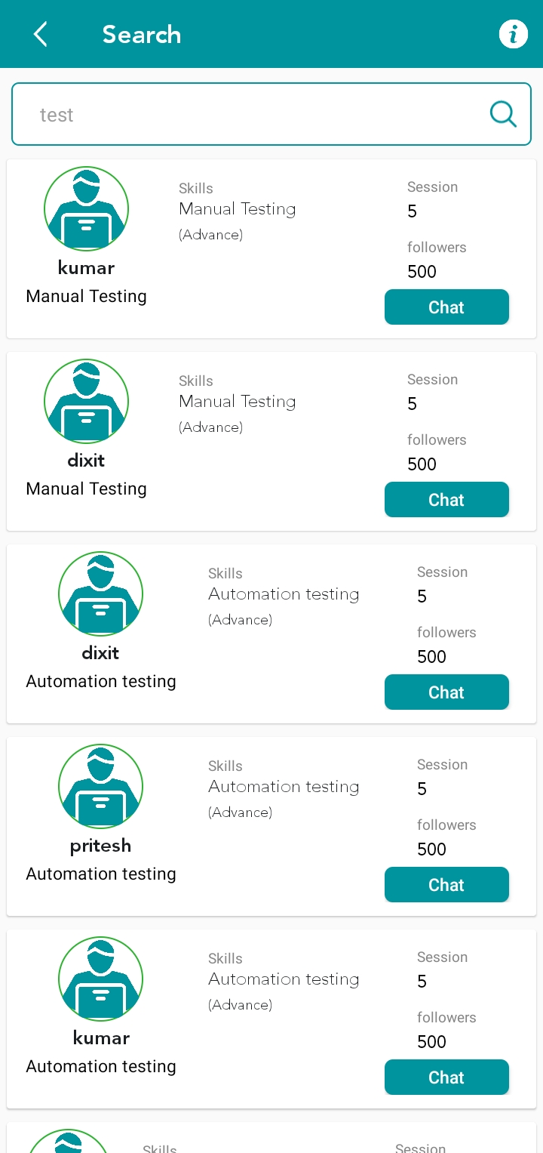

Api:-BaseUrl +/search/global

Method :- Get   
This Api used Global Search

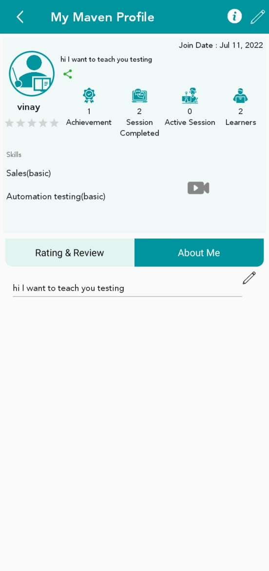

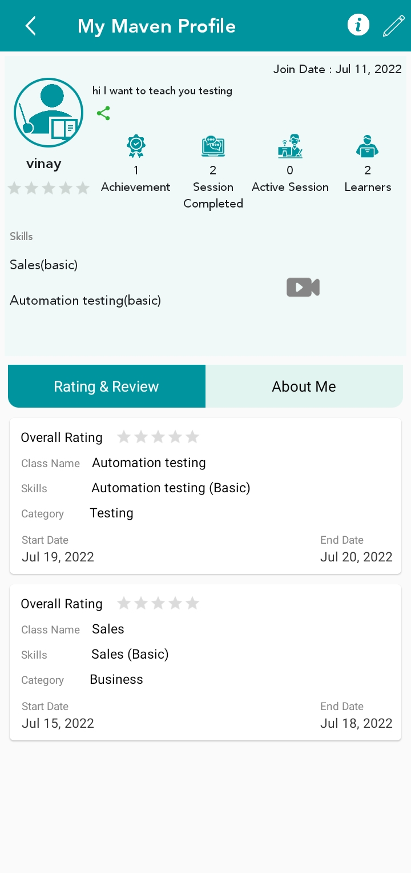

Api:-BaseUrl +/userrequest/getUserClassesByRating  
Method :- Get  
This Api used getUserClassesByRating

Api:-BaseUrl +/ user  
Method :- Get   
This Api used Get Profile Data User

Api:-BaseUrl +/user/note/update

Method :- Post   
This Api used About Update

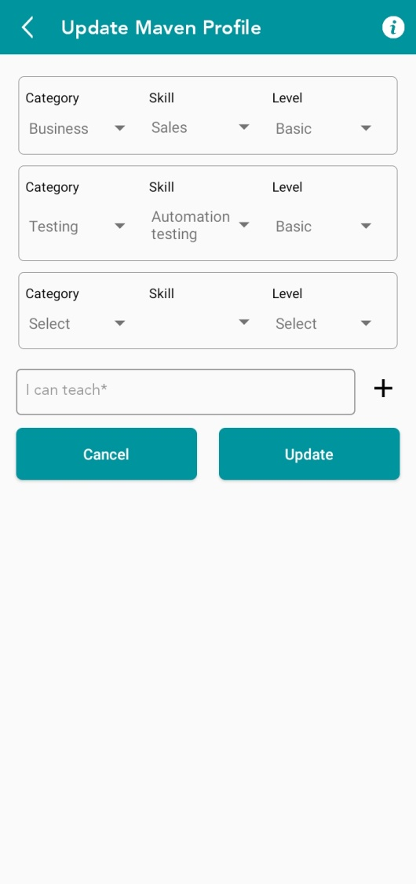

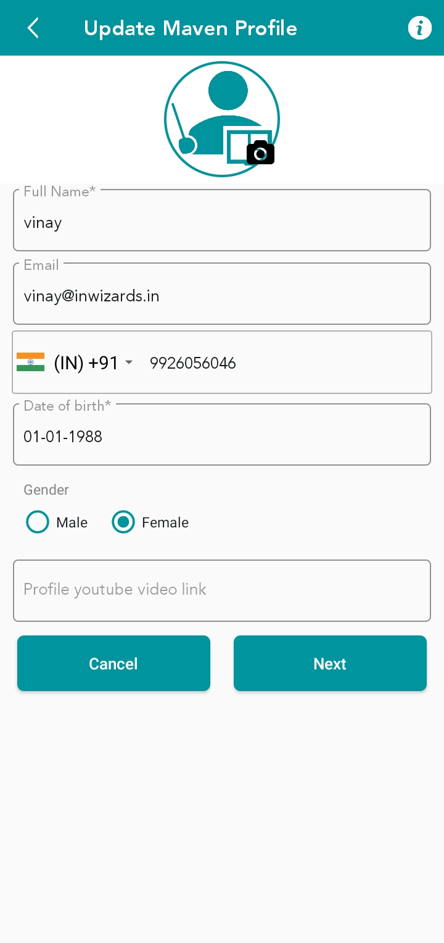

Api:-BaseUrl +/ Tag/createSuggestedTag  
Method :- Post  
This Api used createSuggested New Tag

Api:-BaseUrl +/file/uploads?action=avatar  
Method :- Post  
This Api used Post new image User

Api:-BaseUrl +/category?type=active&addonemoreskill=true  
Method :- Get  
This Api used Get Category

Api :- BaseUrl +/Tag/getAllTag  
method :- Get  
This api used maven site get All Get Tag by Search option in update profile screen  
  
Api :- BaseUrl +/user  
method :- Put  
This api used update profile User

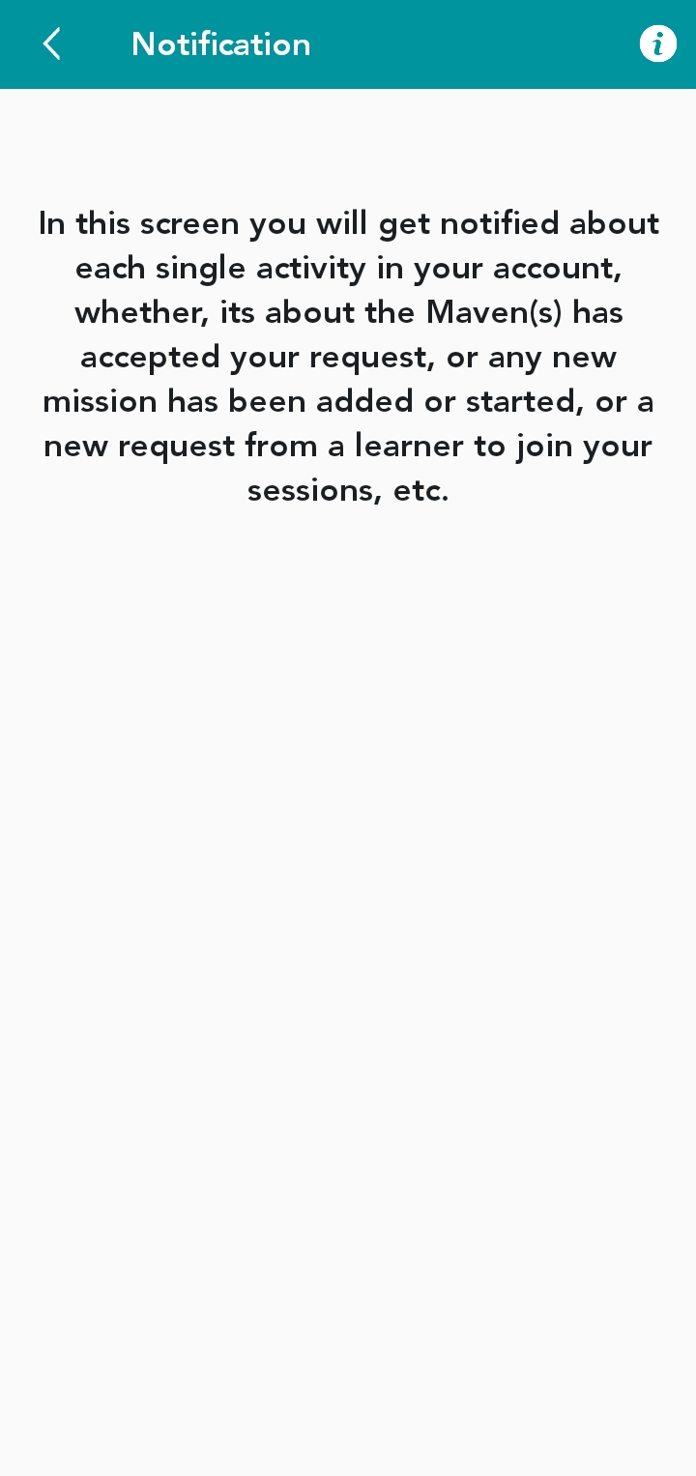

Api:-BaseUrl +/user/notification  
Method :- Post  
This Api used Get notification

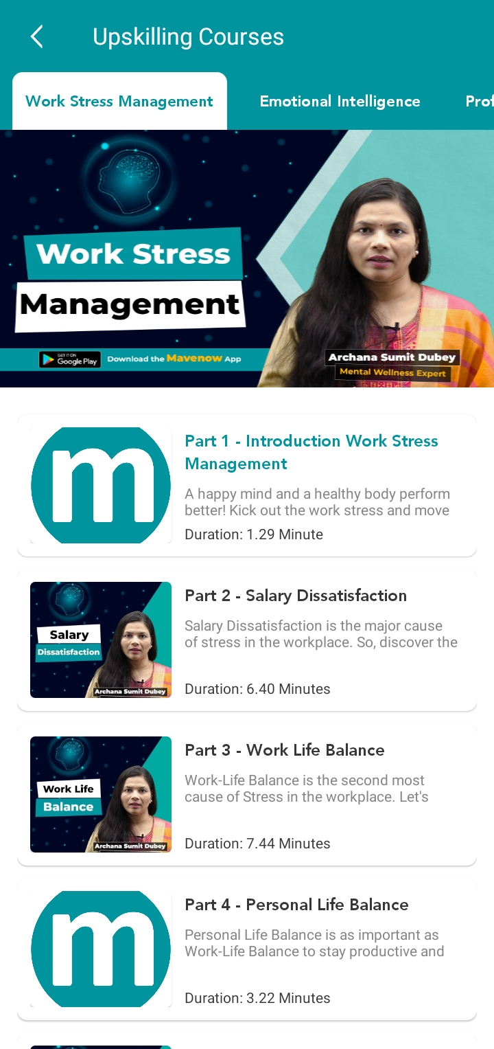

Api:-BaseUrl +/course/GetHighligthVideoListWithCourse  
Method :- Post  
This Api used Get Video list Upskills course Category and video list

Api:-BaseUrl +CourseJoinStudent/CreateCourseJoinStudent  
Method :- Post  
This Api used Payment Api

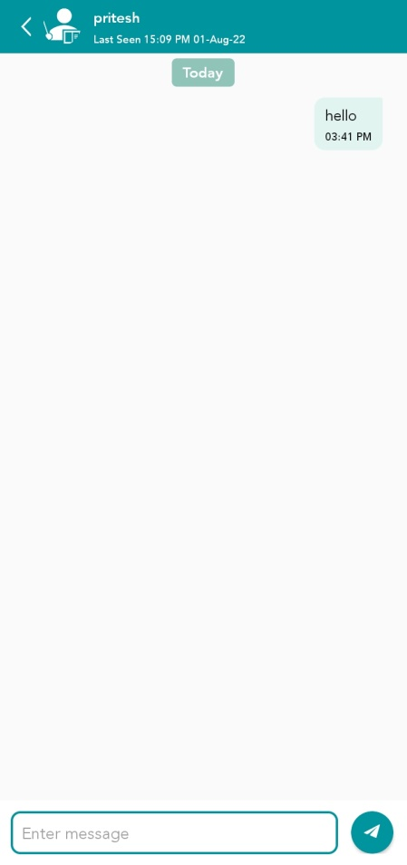

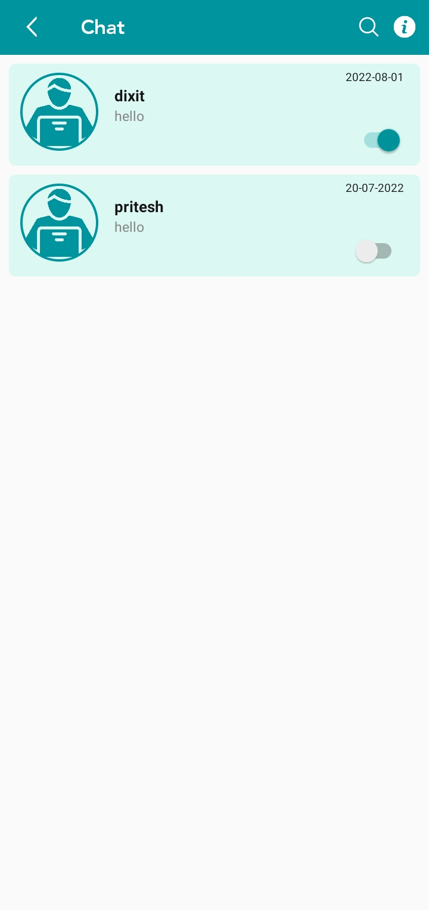

Api:-BaseUrl +/user/firebase/detail  
Method :- Post  
This Api used Get Video list Upskills course Category and video list

**FirebaseBaseUrl :-https://mavenow-a551c-default-rtdb.firebaseio.com**

Api:- FirebaseBaseUrl +/ users.json  
Method :- Post  
This Api used Get User list using firebase and share status typing on firebase

Api:-BaseUrl +/user/userArchive  
Method :- Post  
This Api used User Block and Unblock

Api:-BaseUrl+ /chat/notification  
Method :- Post  
This Api used Get Chat Notification

Api:-BaseUrl + /save/firebase/chat  
Method :- Post  
This Api used Save Message on chat

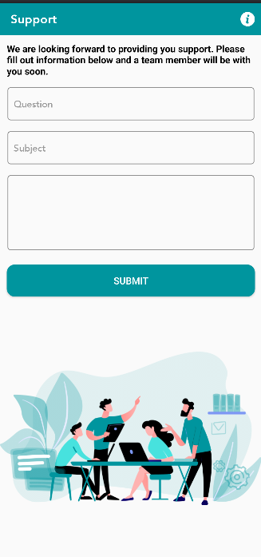

Api:-BaseUrl + api/v2/tickets  
Method :- Post  
This Api used Save Support Question

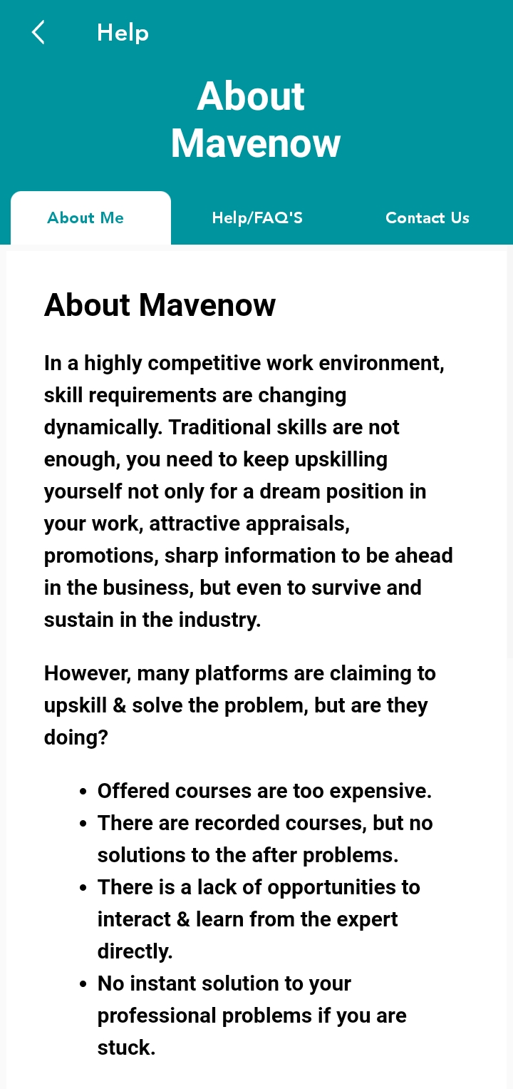

Api:-BaseUrl + /pageContent  
Method :- Get  
This Api used Help Screen in get Html screen About Me, Help/FAQ’s, Contact Us

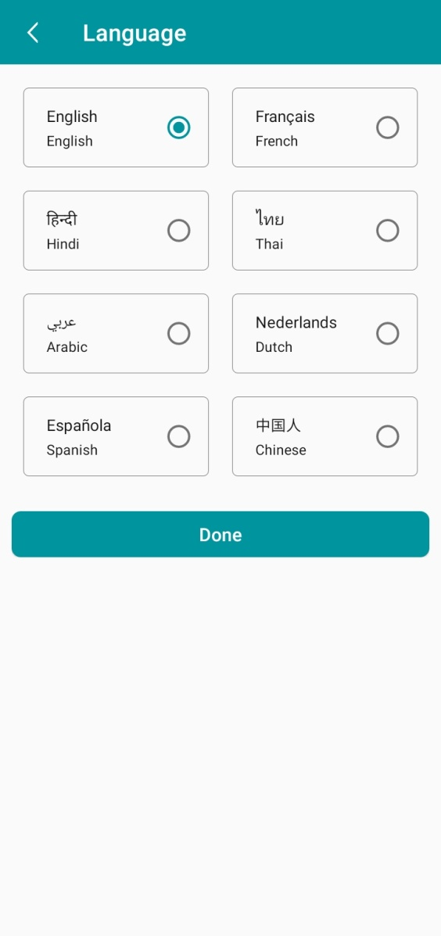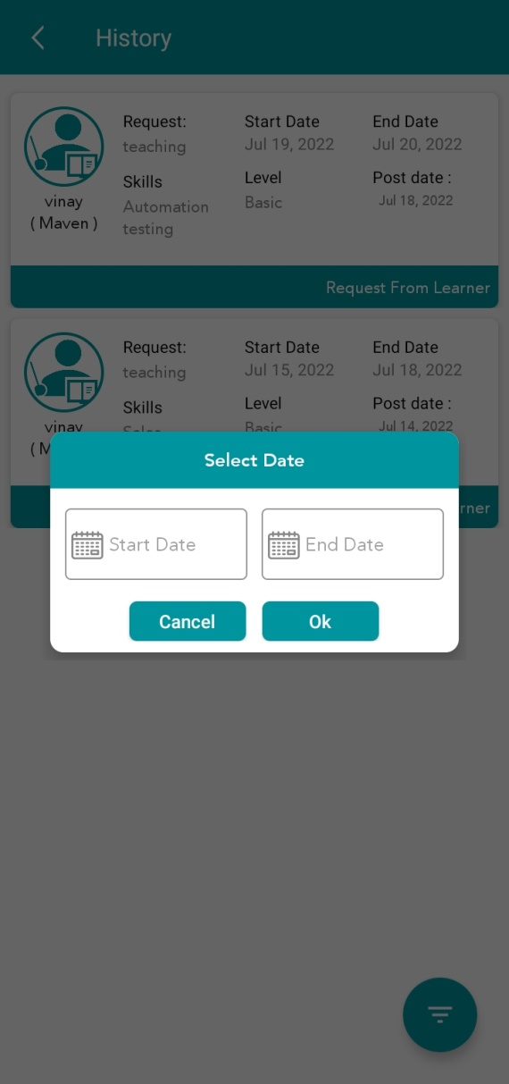

Api:-BaseUrl + / user/GetLanguages  
Method :- Get  
This Api used GetLanguages List

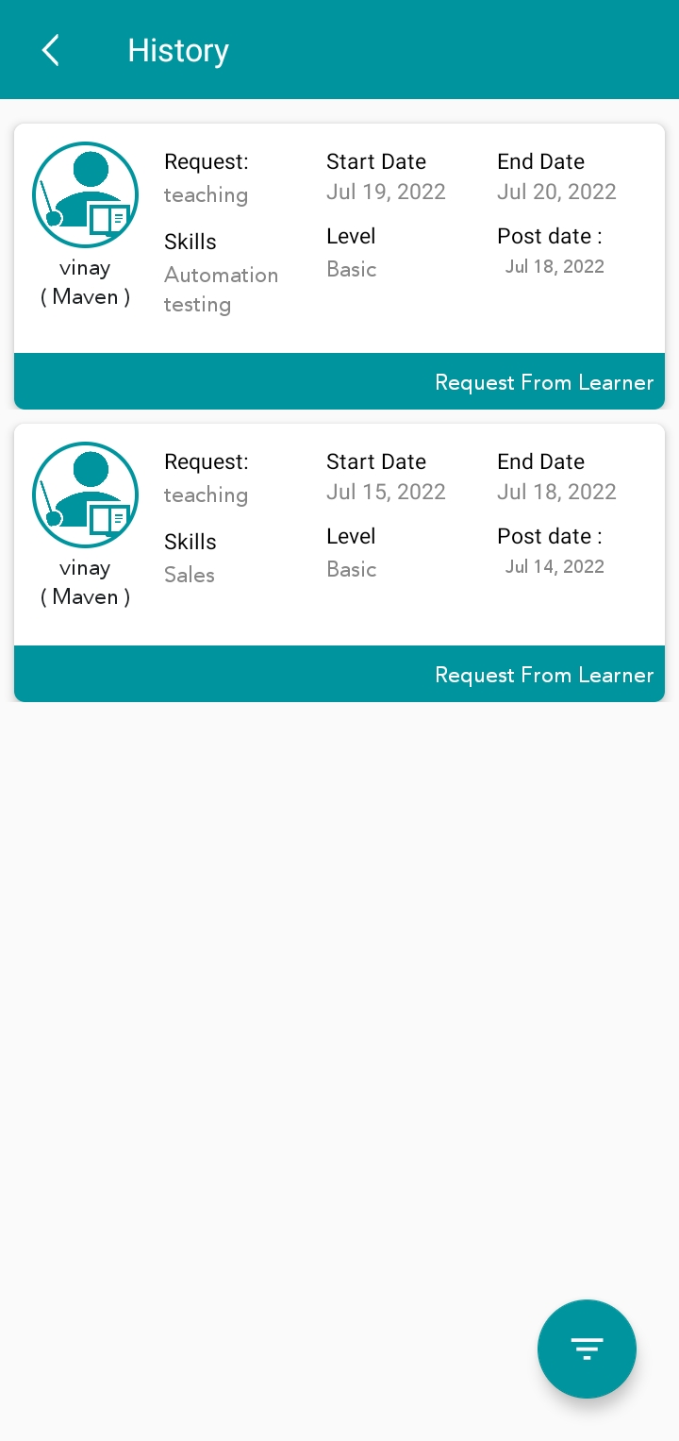

Api:-BaseUrl + /userrequest/history  
Method :- Get  
This Api used Gethistory List

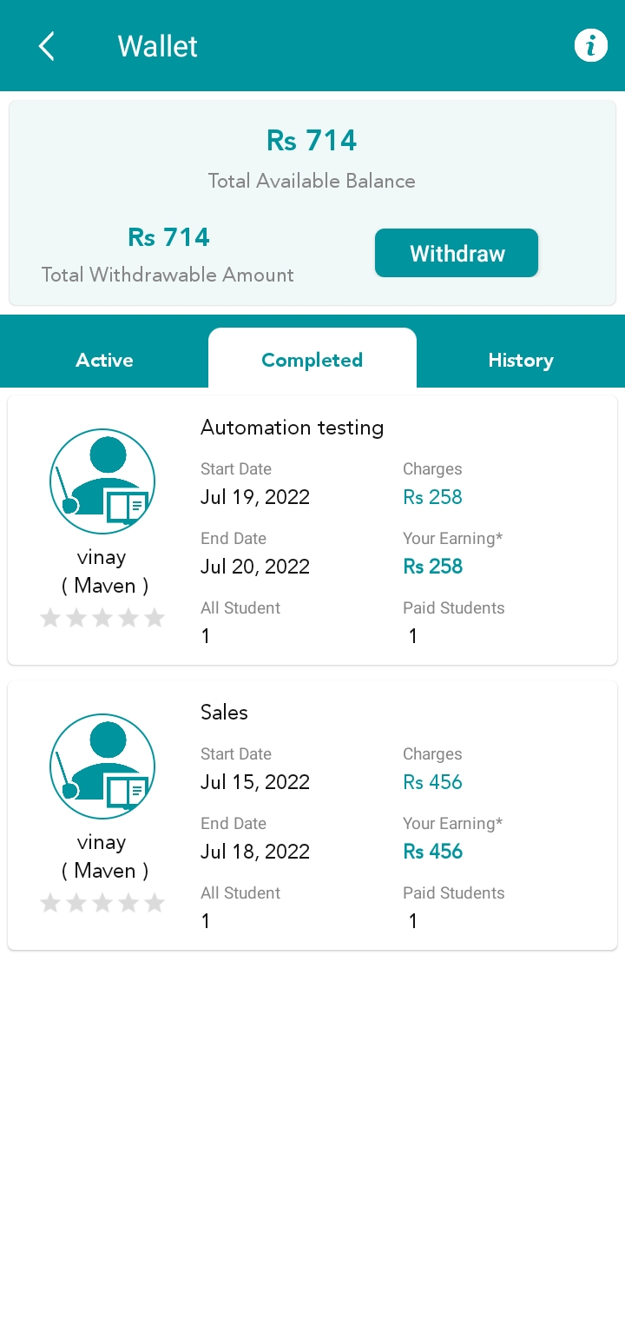

Api:-BaseUrl + /wallet  
Method :- Get  
This Api used Getwallet List Active , Completed , History

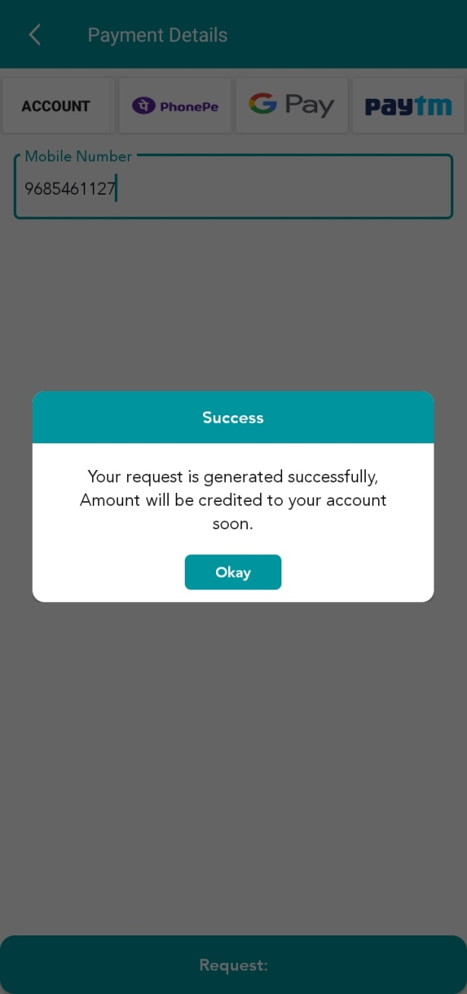

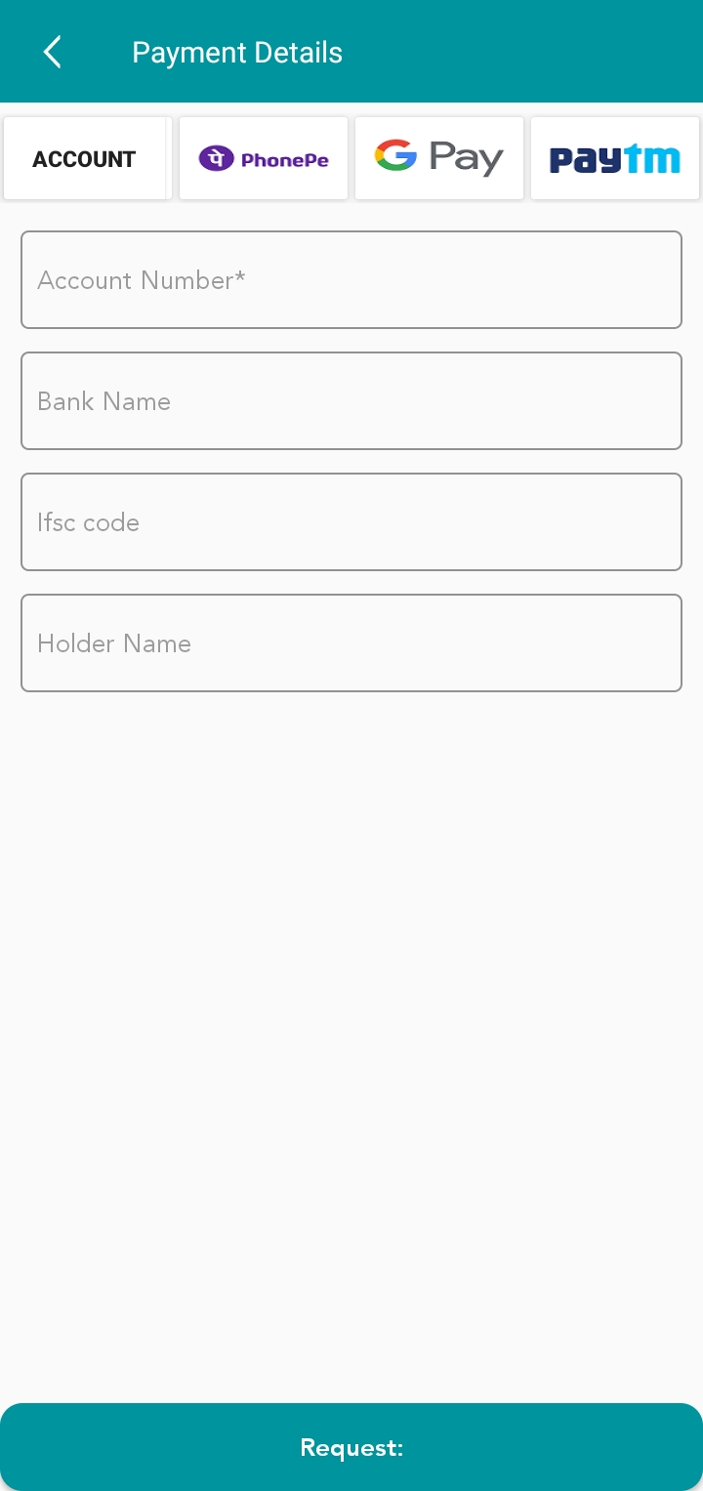

Api:- BaseUrl +/ wallet/requestForWithdrawal  
Method :- Post  
This Api used Post Withdraw  
  
Api:- BaseUrl +/ wallet/requestForRefund  
Method :- Post  
This Api used requestForRefund

Api:-BaseUrl +/ wallet/acount  
Method :- Get  
This Api used Get Account Details

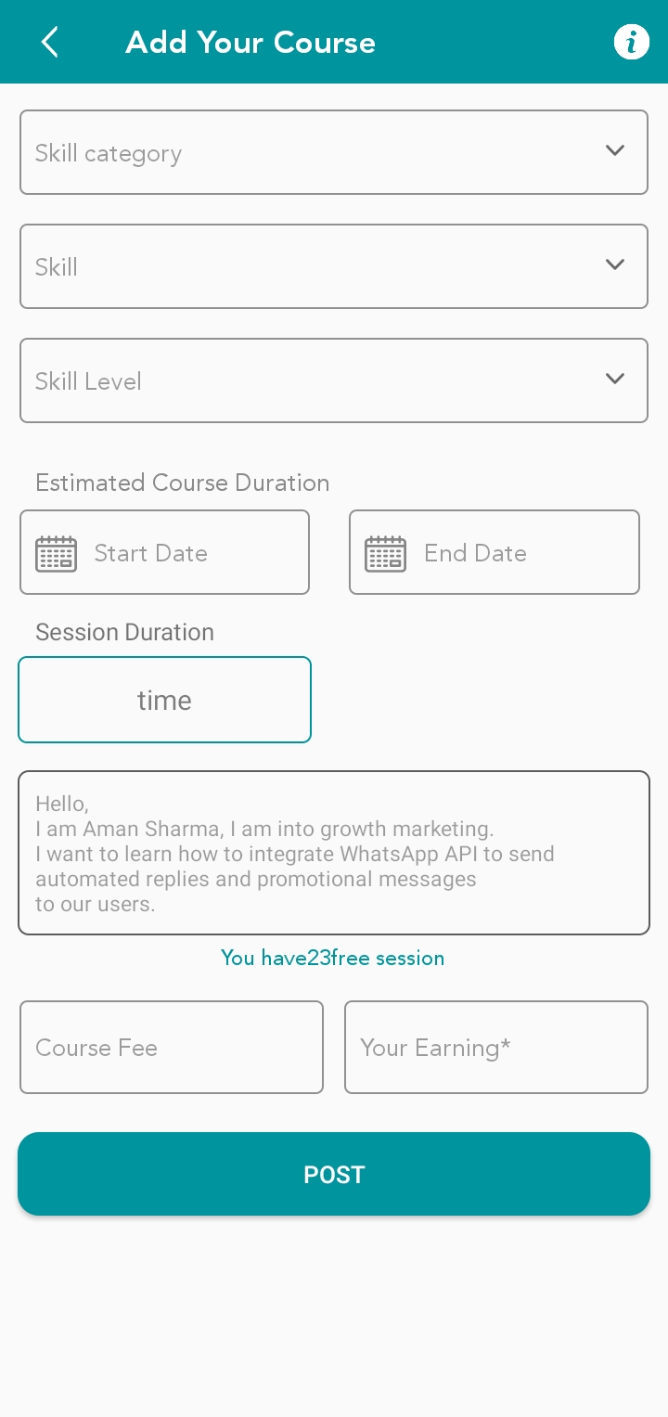

Api:-BaseUrl +/usercategory  
Method :- Get  
This Api used Get User Category

Api:-BaseUrl + /setting?name=teachingCharges  
Method :- Get  
This Api used Get App Service Charge

Api:-BaseUrl +/skills/ByCategory  
Method :- Post  
This Api used Get skills ByCategory

Api:-BaseUrl +/userrequest/add  
Method :- Post  
This Api used Maven post request

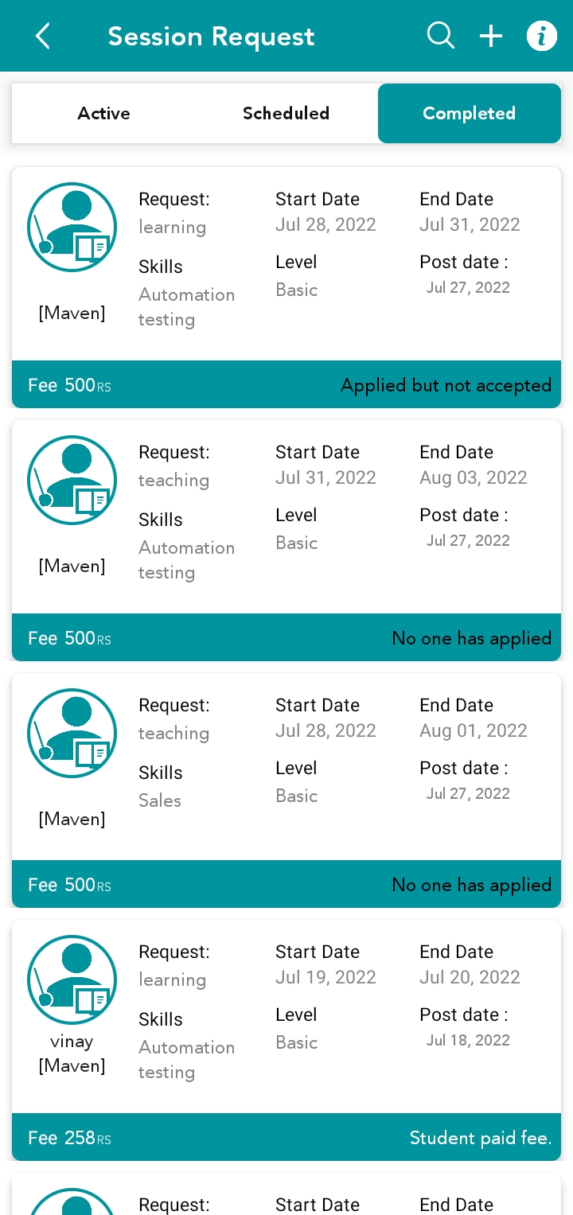

Api:-BaseUrl + /userrequest/AppliedRequets  
Method :- Post  
This Api used Get Data Active List maven and Learner Site

Api:-BaseUrl +/userrequest/ProcessRequets  
Method :- Post  
This Api used Get Data Scheduled Listmaven and Learner Site

Api:-BaseUrl + /userrequest/CompleteRequest  
Method :- Post  
This Api used Get Data CompleteListmaven and Learner Site

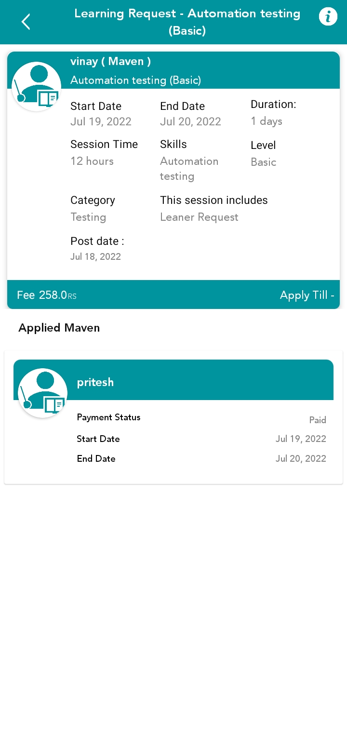

Api:-BaseUrl + /userrequest/Processing/discipleormaster  
Method :- Get  
This Api used Get Data Processing Details maven and Learner Site

Api:-BaseUrl + /userrequest/getListOfCandidateAgainstARequest  
Method :- Get  
This Api used getListOfCandidateAgainstARequest

Api:-BaseUrl +/add/Wallet/TransactionDetail  
Method :- Post  
This Api used payFor Maven

Api:-BaseUrl +/add/Paypal/TransactionDetail  
Method :- Post  
This Api used send Money

Api:-BaseUrl +/userrequest/hireCandidate  
Method :- Post  
This Api used CandidateConnection

Api:-BaseUrl +/userrequest/Processing/discipleormaster  
Method :- Get  
This Api used startClassUserList  
  
Api:- BaseUrl +/createOnlineMeeting  
Method :- Get  
This Api used Create Session

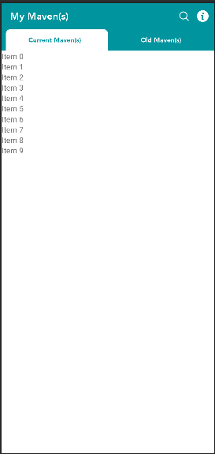

Api:-BaseUrl + /user/discipleOrMaster  
Method :- Post  
This Api used Maven list New / Old

Api:-BaseUrl + payment/payToTeacher  
Method :- Post  
This Api used Payment status update

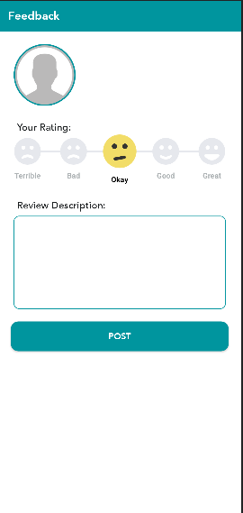

Api:-BaseUrl + /user/feedback  
Method :- Post  
This Api used Post Feedback

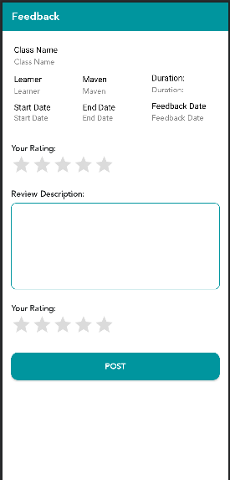

Api:-BaseUrl + /GetFeedbackQuestion  
Method :- Post  
This Api used Post GetFeedbackQuestion

Api:-BaseUrl + /AttemptFeedback  
Method :- Post  
This Api used Post FeedbackQuestion Answer



Socket :-BaseUrl + /sendchat  
Method :- Emit  
This Api used Post Send Data of User details

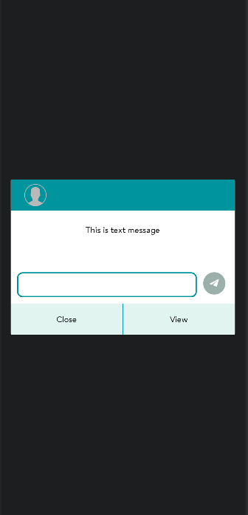

Api:-BaseUrl + /chat/notification  
Method :- Post  
This Api used Send Notification of On Reply Chat Notification

Api:-BaseUrl + /save/firebase/chat  
Method :- Post  
This Api used saveLastMessage

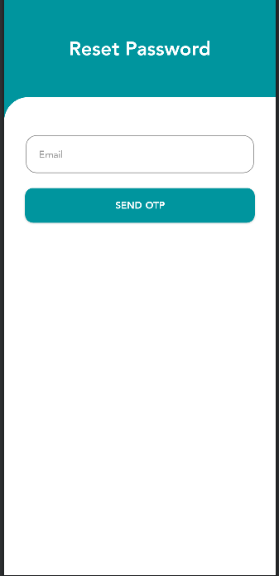

Api:-BaseUrl + /users/forgotpassword  
Method :- Post  
This Api used sendOtp

Api:-BaseUrl + /user/checkSecurityToken  
Method :- Post  
This Api used verifyOTP

Api:-BaseUrl + /user/changePasswordBySecurityToken  
Method :- Post  
This Api used changePassword

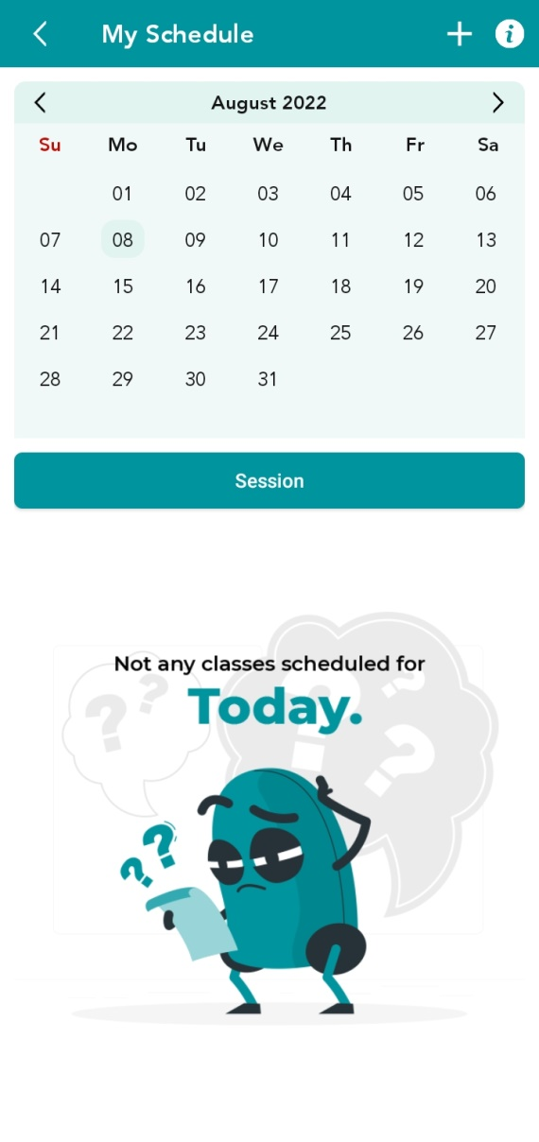

Api:-BaseUrl + /calendarData/detail/byDate  
Method :- Post  
This Api used calendar Data detail byDate

Api:-BaseUrl + /calendarData/foruser  
Method :- Post  
This Api used gettingcalendarData

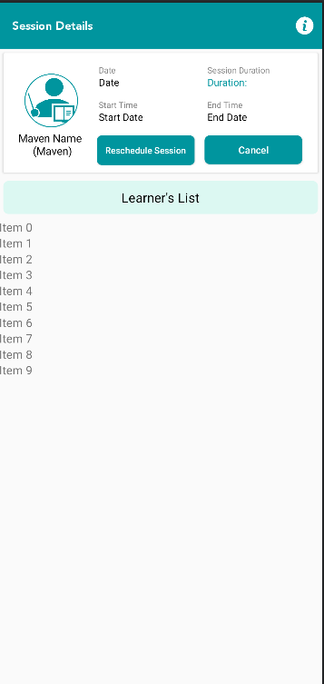

Api:-BaseUrl + /userrequest/getUserClassById  
Method :- Get  
This Api used getClassData

Api:-BaseUrl + /cancelorrescheduleclass  
Method :- Post  
This Api used cancelorrescheduleclass

Api:-BaseUrl + /classAttedance  
Method :- Post  
This Api used sendClassAttend

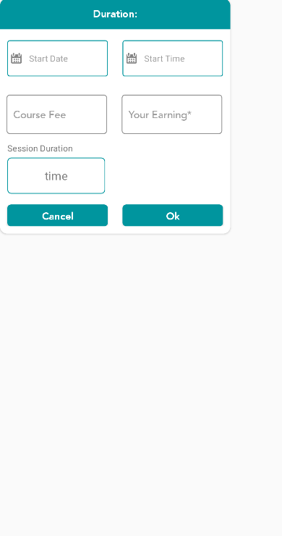

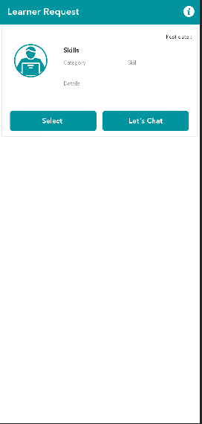

Api:-BaseUrl + /setting?name=teachingCharges  
Method :- Get  
This Api used getAppCharges

Api:-BaseUrl + /userrequest/Detail  
Method :- Get  
This Api used getrequestData

Api:-BaseUrl + /userrequest/Apply  
Method :- Post  
This Api used applyAgainst

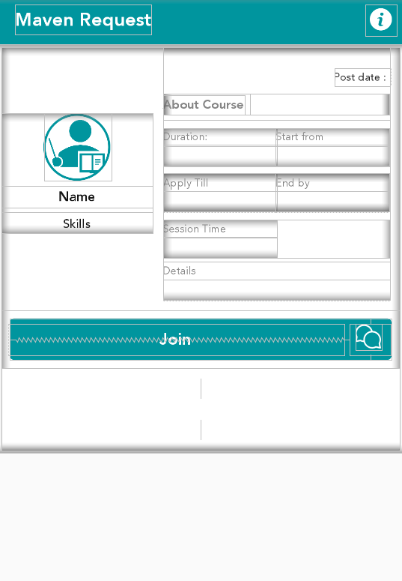

Api:-BaseUrl + /userrequest/Detail  
Method :- Get  
This Api used getRequestData

Api:-BaseUrl + /userrequest/Apply  
Method :- Post  
This Api used applyAgainst

**ReviewActivity1 screen**

Api:-BaseUrl +/userrequest/getUserClassesByRating  
Method :- Get  
This Api used getUserClassesByRating

**ReviewclassRatingActivityScreen**

Api:-BaseUrl+/userrequest/getUserClassRatings  
Method :- Get  
This Api used getUserClassRatings

**StudentPayActivity Screen**

Api:-BaseUrl+ /wallet/class/students  
Method :- Get  
This Api used getStudentWalletData

**TransactionHistoryFragment screen**

Api:-BaseUrl+ /wallet/Transactions  
Method :- Get  
This Api used getAllTransaction